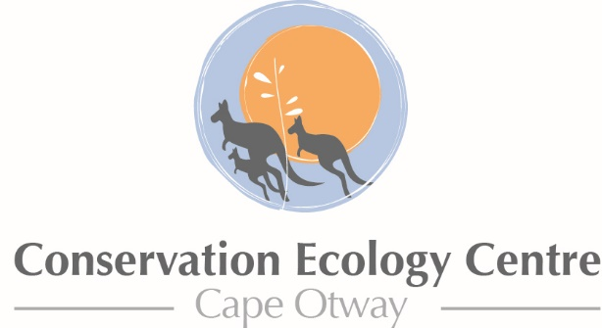

Research Student Scholarship Program 201 7

Application Form

Completed applications are to be emailed to Dr Jack Pascoe, Conservation and Research Manager at the Conservation Ecology Centre at jack@conservationecologycentre.org

Student Name: | Click here to enter text. | Primary Supervisor: | Click here to enter text.
Project Name | Click here to enter text. | Position: | Click here to enter text.
University: | Click here to enter text. | Email Address: | Click here to enter text.
Faculty/Department: | Click here to enter text. | Mobile: | Click here to enter text.
Enrolled Degree: | ☐Honours  ☐Masters  ☐PhD | Secondary Supervisor: | Click here to enter text.
Degree Completion Date: | Click here to enter a date. | Position: | Click here to enter text.
Email Address: | Click here to enter text. | Email Address: | Click here to enter text.
Mobile: | Click here to enter text. | Mobile: | Click here to enter text.

Project Information
Project Title: Click here to enter text.
Note: Subject Species or Regional Ecosystem/Vegetation Group (if applicable).Click here to enter text.

Field site locations
Please give general description including local government area and National Parks, reserves or private land if applicable.
Click here to enter text.

Schedule
Month (estimated dates) for field work to be undertaken:
Click here to enter text.

Additional Information
Please provide the following information, in addition to this form:
Please include a project description which includes the aims and objectives of the project and as much detail as possible regarding the methodology and analysis to be conducted. Also include relevant information if this project contributes to a larger project and outline. Outline how this research will contribute to our knowledge of koala management and/or ecology in the Otways.
An estimated project budget including any other contributions.
How the CEC could assist the project beyond finances.
Click here to enter text.

Please provide the following information in a cover letter, in addition to this form:
- A project budget including any other contributions.
- How the CEC could assist the project beyond the scholarship.
- A curriculum vitae

Conditions of Application

I, _________________________________________,
agree to the following conditions should my application be successful:

- The project Supervisory Panel will include a CEC researcher;
- Recognition of the assistance of the CEC will be made in any publications, conference posters or presentation, including the use of the CEC’s logo where appropriate.
- A summary of the funded research will be provided to the CEC by November 2nd 2016;
- Contributions of information and images will be made to CEC’s eNewsletter, website and other digital media as appropriate;

 |  |  | Click here to enter a date. |  |  |  |  | Click here to enter a date.
Student Signature |  |  | Date |  | Supervisor Signature |  |  | Date

